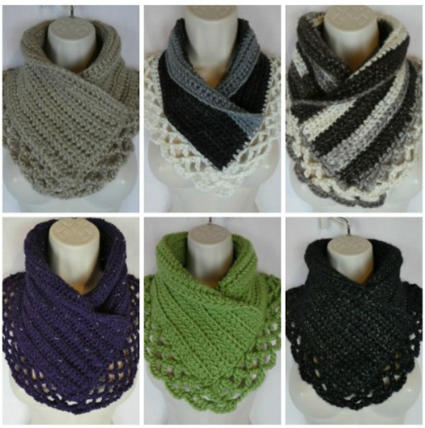
Materials:
- I hook, 5.5 MM
- Super bulky (6) yarn (I used Isaac Mizrahi Craft in “Carlyle”), about 140 yards, a little over a skein
- Bulky (5) yarn such as Bernat Softee Chunky Yarn
- Medium worsted weight (4) yarn (I used Red Heart With Love Metallic in “Olive”, about 180 yards (less than a skein).
- Blunt needle
Abbreviations:
sc- single crochet
hdc- half double crochet
st(s)- stitch(es)
BLO- back loops only
FLO- front loops only
Sl st- slip stitch

The pattern:
Ch 80 for super bulky weight yarn (size 6), ch 86 for bulky weight yarn (size 5), Ch 98 for medium worsted weight yarn (size 4). It’s ok if you need a few more or less stitches, so long as the foundation chain measures 29″.
Row 1: Hdc in 3rd ch from the hk and each st across.
Row 2: Ch 2, hdc in BLO in each st across.
Row 3: Ch 2, hdc in FLO in each st across.
Rows 4-10 (for super bulky yarn), 4-12 (for bulky and medium worsted weight yarn) : Repeat rows 2 and 3.

Sewing:
Position the scarf so one side goes over the other side coming to a point in the front. I always try it on in a mirror first to make sure the fit is just what I like before sewing.
Once you have it positioned where you like, sew through both layers at 3 points: on each corner where the top part of the scarf overlaps and on the other side. Weave in ends.
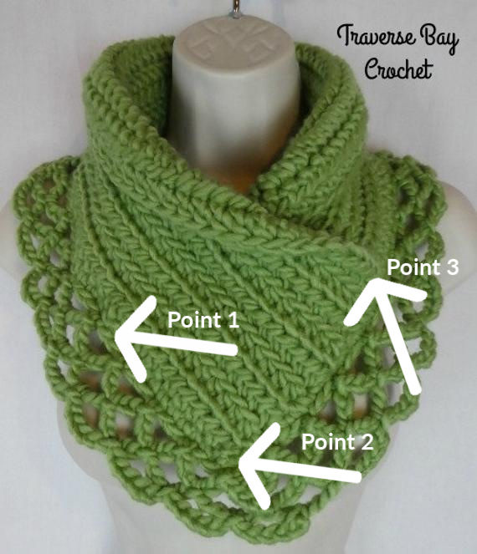
Edging:
Pick up a loop anywhere around the edging of the scarf and sc 81 for super bulky weight, 87 for bulky weight yarn, 90 for medium worsted weight yarn (doesn’t have to be exact but needs to be a multiple of 3) evenly around (sc through both overlapping areas). Sl st in last st.
Row 1: *Ch 5, skip next 2 sts, sl st in next st,* repeat from * around, ending with ch 5.
Row 2: Sl st in first ch 5 space, ch 5 sts, *sl st in next ch 5 space, ch 5 sts,* repeat around, ending with ch 5.
Rows 3: *Sl st in next ch 5 space, ch 5 sts,* repeat around, ending with ch 5.
***Fasten off and weave in end here for super bulky weight yarn. For bulky and medium weight yarn continue with rows 4 and 5.***
Rows 4-5: repeat row 2. On row 5 end with a sl st into the first ch 5 space and fasten off. Weave in end.
You’re done! Great job! You can keep the collar straight or roll it over for a different look. Either way you’ll look great!

Don’t forget to save to your Pinterest boards!

